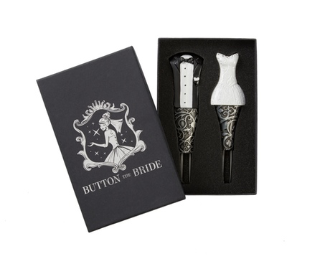

The Story of Button The Bride

Along with mementos old, new, borrowed, and blue, today no bride's trousseau is complete without Button the Bride, the essential tool for fastening loops over fabric-covered bridal buttons. An elegant keepsake and an indispensable device for getting the bride in and out of her wedding dress, the story behind Button the Bride proves that necessity really is the mother of invention.

For nearly 30 years, Susie Gray Uphues has followed her passion for beauty, working her way up from a small cosmetics counter in Paris, Texas, to representing some of the most prominent names in the cosmetics industry. Today, Susie does make up for celebrities, models, and brides in and around the Dallas area.

As a single mother in the late 1980's, Susie moved to Dallas, Texas, where she began working for Neiman Marcus. Eight years later, Susie left the department store behind and freelanced for a few years until she found a dream job with Bobbi Brown.

Susie travelled all over the world for Bobbi, training other artists, including a stint at London's famous Selfridges. Loving the artistry but not so keen on the retail side of makeup, fifteen years later Susie left the cosmetics company and ultimately signed with The Campbell Agency to work on photo and video shoots.

While doing makeup offers Susie a taste of glamour, such as when she had the opportunity to work with Gwyneth Paltrow, making ends meet as a makeup artist as a single mother can be a challenge. Of the many ways Susie found to fill in the gaps over the years, perhaps the most rewarding has been doing makeup for high-end weddings.

After years of holding brushes and buttoning brides (since her nails are short for applying makeup, Susie usually helped with the difficult, delicate buttons), Susie's right thumb eventually gave out and required surgery. Stuck in a cast and left with only two fingers to practice her craft, Susie struggled through the toughest time of her career as a makeup artist, and she was forced to watch helplessly as her brides, their maids, and their mothers struggled to fasten the loops on their beautiful dresses. One day, Susie overheard a frustrated mother exclaim, "I can't believe someone hasn't come up with something already!"

Remarkably, no one had, so Susie set to work to create the perfect solution. From a humble beginning of two crochet hooks taped to an ink pen, Susie spent the next year-and-a-half designing and developing (with the help of a wonderful commercial artist and an excellent manufacturer) the elegant and durable finished product – the only one of its kind.

Beginning with the mechanics, Susie knew the functional end of the tool had to be as strong as the metal crochet hooks of the prototype. Today, it consists of a pair of metal prongs, one with a hook on the end, that are slid into the loop, which is then easily pulled up and over the delicate button.

Susie also wanted the handle to be easy to grip, as well as aesthetically pleasing and in the shape of a woman in a bridal dress. Searching Amazon for wedding favors, she knew she had hit pay dirt when she discovered a dress and tuxedo set of wine stoppers.

Not only was the bride stopper a perfect model for the Button the Bride handle, but the groom stopper inspired Susie too: Since the groom will eventually want to get the bride out of the dress… Button the Bride should come as a set!

In order to accommodate the groom's unique mission, the men’s version was modified to have shorter tines but a larger hook, making unbuttoning that much easier. And, since the handle is broader and flat, it became the ideal place to engrave a personal message to mark the special day.

During the nearly two years of development, Susie's daughter, April, joined the project as a partner, and in May 2015, together they launched a Kickstarter campaign that reached its goal within one month thanks to the generous pledges of their 85 backers.

While April and Susie will formally launch Button the Bride in October 2015 at New York's International Bridal Week, brides in Dallas are already using the product with terrific results. As one bridesmaid exclaimed while helping her friend into her gorgeous wedding dress, "This is awesome. It's so much easier than doing it by hand."

Susie and April are enormously grateful to all their backers, as well as for the love and support of their husbands, Chris Uphues and Trent Davis, and April's adorable daughter, Presley. Susie and Chris live in Dallas with their boxer, Momo.

http://www.buttonthebride.com
https://www.facebook.com/Buttonthebride

